1. Inventory List

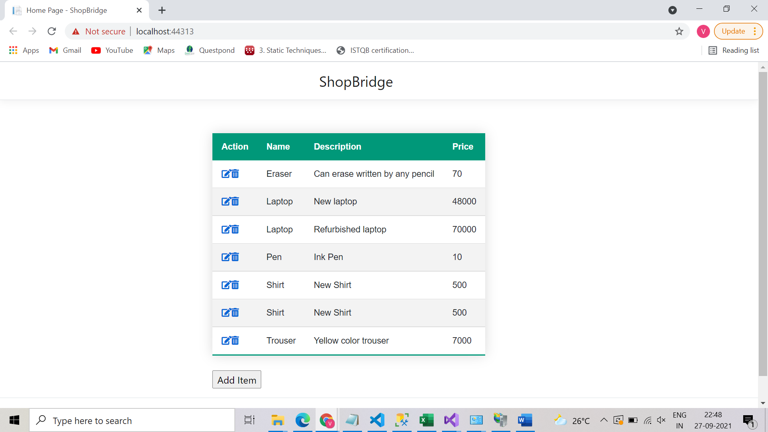

1. Click on “Add Item” button to add any new item

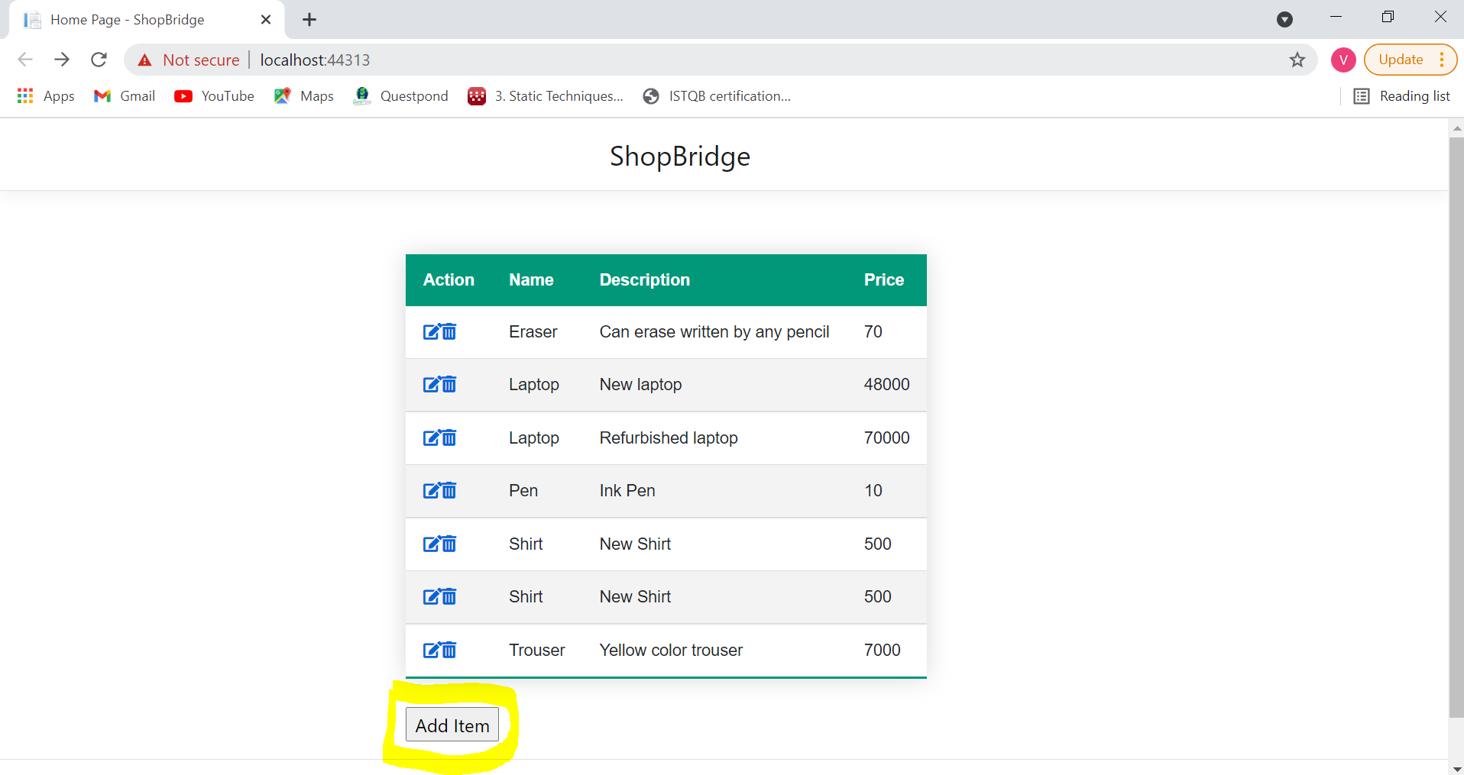

A new page will appear to add item details. Provide the details and click on Submit button:

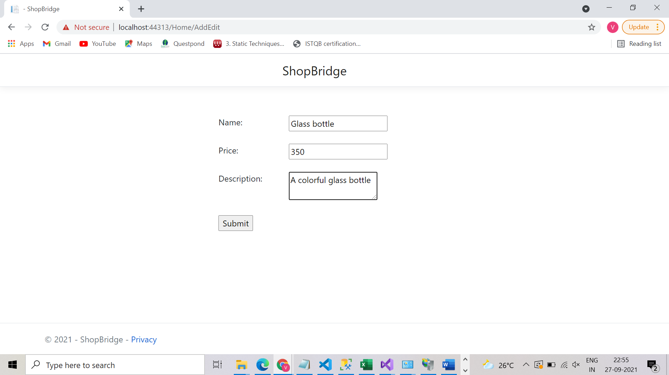

The item should be added to the inventory item list.

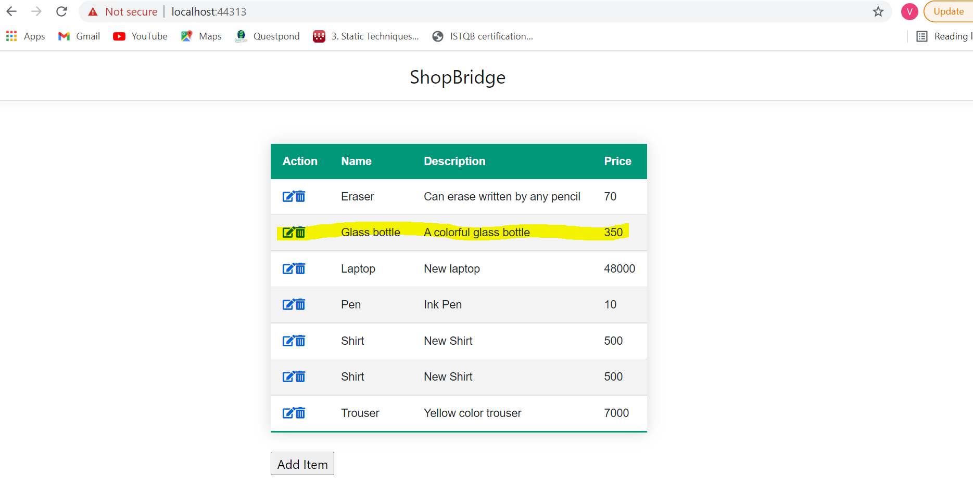

1. Click on the edit button on any row in the first column to edit:

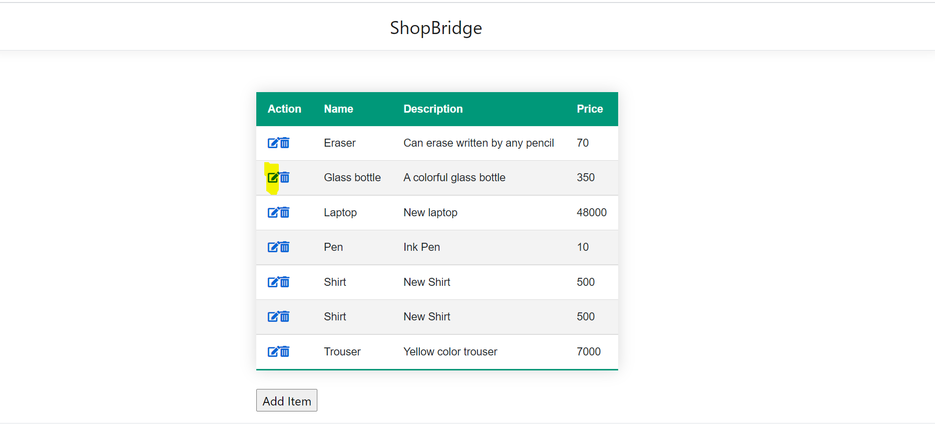

In the next page edit the items:

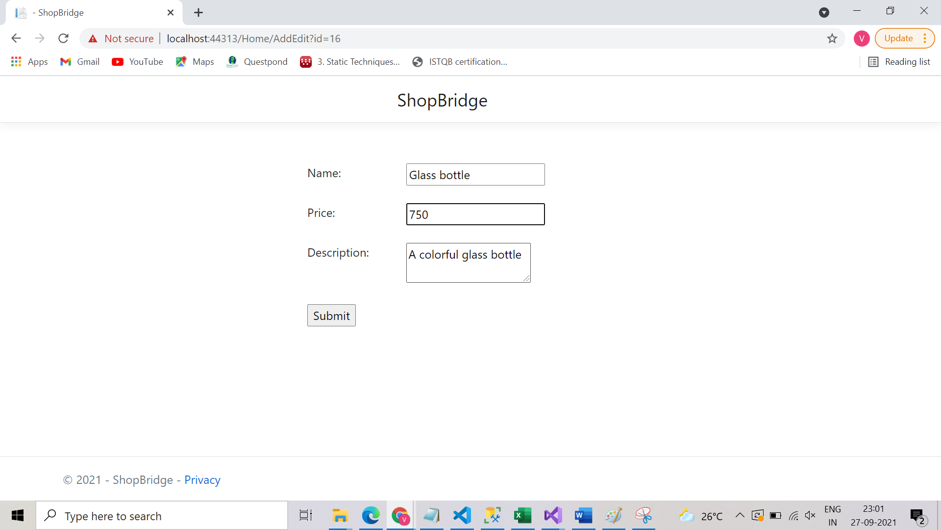

Click on Submit

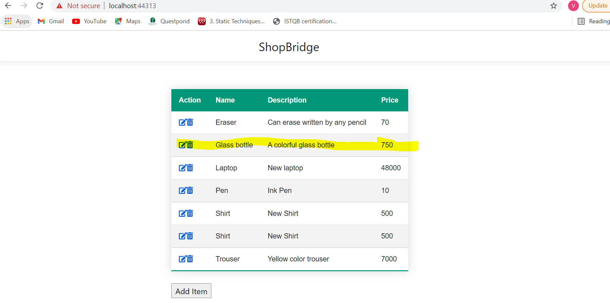

1. Delete : Click on the delete button in the first column of any row:

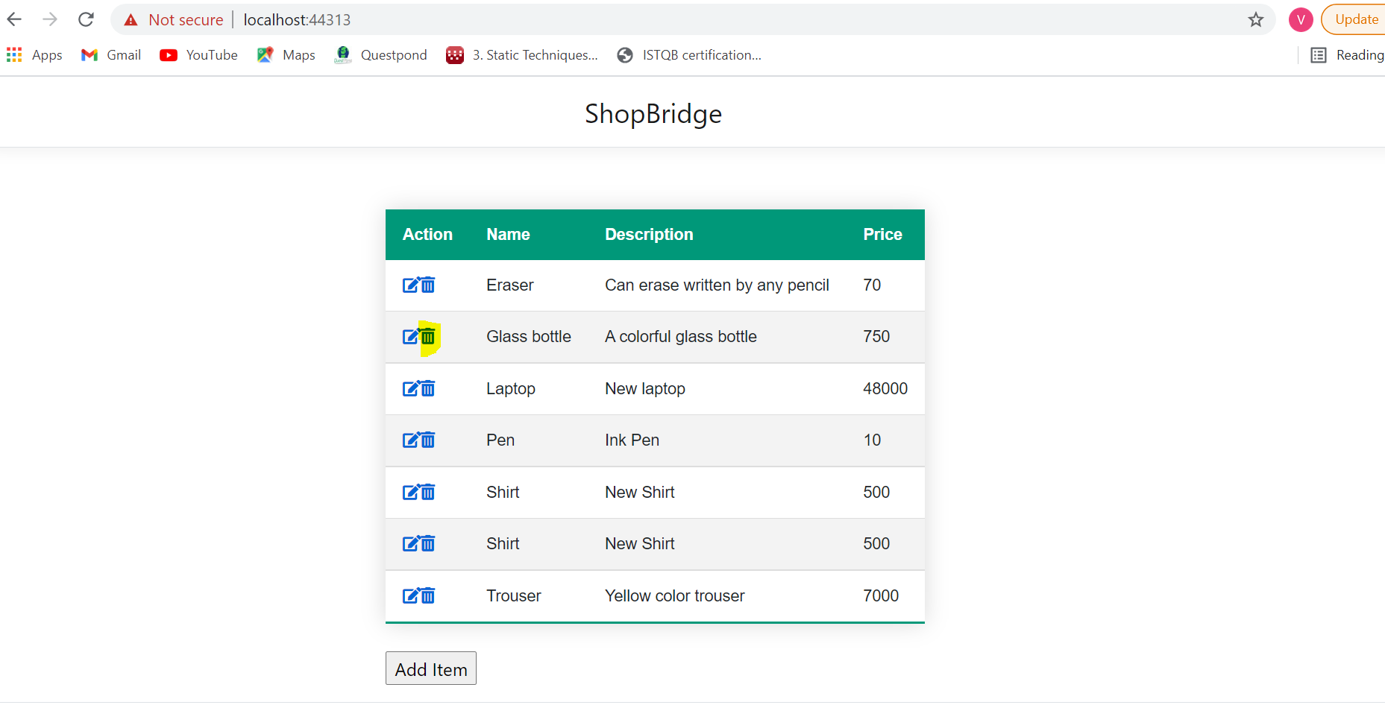

Click on the item and it will be removed from inventory list.

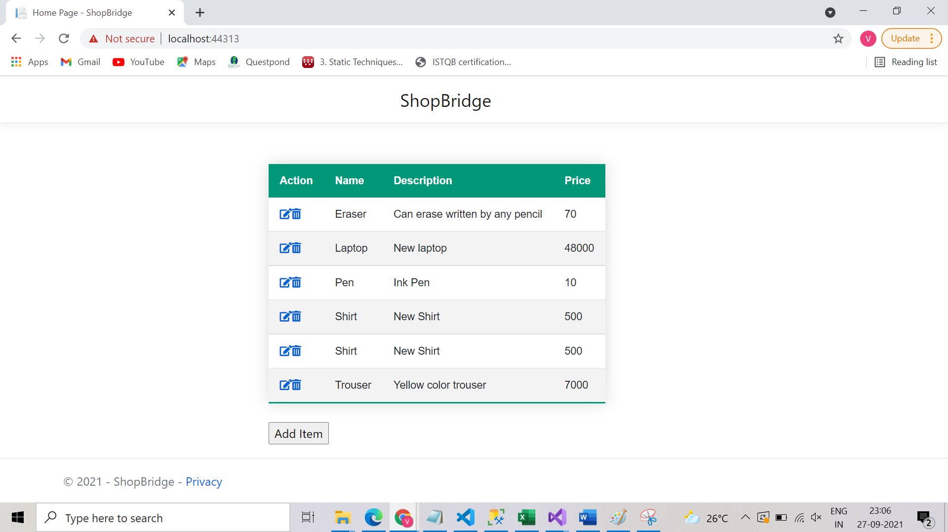

Time Tracking:

1.Data store design : 1 hr

2. API and service logic : 2 hrs

3. Front End : 6 hrs

4. Unit Test Coverage : 1.5 hrs